Lab Report No 2



Digital Signal Processing

Submitted By: Maaz Habib

Registration No: 20PWCSE1952

Section:c

“On my honor, as student of University of Engineering and Technology, I have neither given nor received unauthorized assistance on this academic work”

Student Signature:

Department of Computer Systems Engineering

University of Engineering and Technology Peshawar

**CSE 402L: Digital Signal Processing**

|  |  |  |  |  |
| --- | --- | --- | --- | --- |
| **Demonstration of Concepts** | **Poor (Does not meet expectation (1))**  The student failed to demonstrate a clear understanding of the assignment concepts | **Fair (Meet Expectation (2-3))**  The student demonstrated a clear understanding of some of the assignment concepts | **Good (Exceeds Expectation (4-5)**  The student demonstrated a clear understanding of the assignment concepts | **Score**  **30%** |
| **Accuracy** | The student completed (<50%) tasks and provided MATLAB code and/or Simulink models with errors. Outputs shown are not correct in form of graphs (no labels) and/or tables along with incorrect analysis or remarks. | The student completed partial tasks (50% - <90%) with accurate MATLAB code and/or Simulink models. Correct outputs are shown in form of graphs (without labels) and/or tables along with correct analysis or remarks. | The student completed all required tasks (90%-100%) with accurate MATLAB code and/or Simulink models. Correct outputs are shown in form of labeled graphs and/or tables along with correct analysis or remarks. | **30%** |
| **Following Directions** | The student clearly failed to follow the verbal and written instructions to successfully complete the lab | The student failed to follow the some of the verbal and written instructions to successfully complete all requirements of the lab | The student followed the verbal and written instructions to successfully complete requirements of the lab | **20%** |
| **Time Utilization** | The student failed to complete even part of the lab in the allotted amount of time | The student failed to complete the entire lab in the allotted amount of time | The student completed the lab in its entirety in the allotted amount of time | **20%** |

Lab No: 2.

Title: Signal Analysis in both time and frequency domain using Matlab

Provide .m file with detailed comment:

**Task 1:**

1. Will generate the signal of different frequencies say, 10,20,30,40,50,60 Hz (one second duration) using Matlab as shown in figure 1 and transform the same signal in frequency domain using Fourier transform and will compare the frequencies with the time domain signal as shown in figure 2.

**Code 1:**

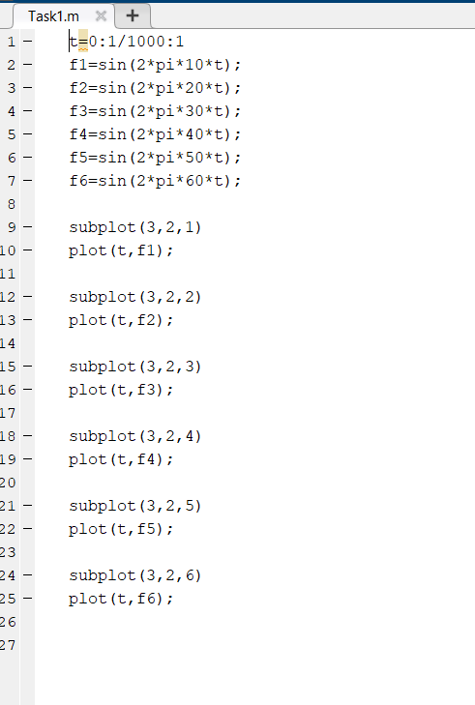

**Output:**

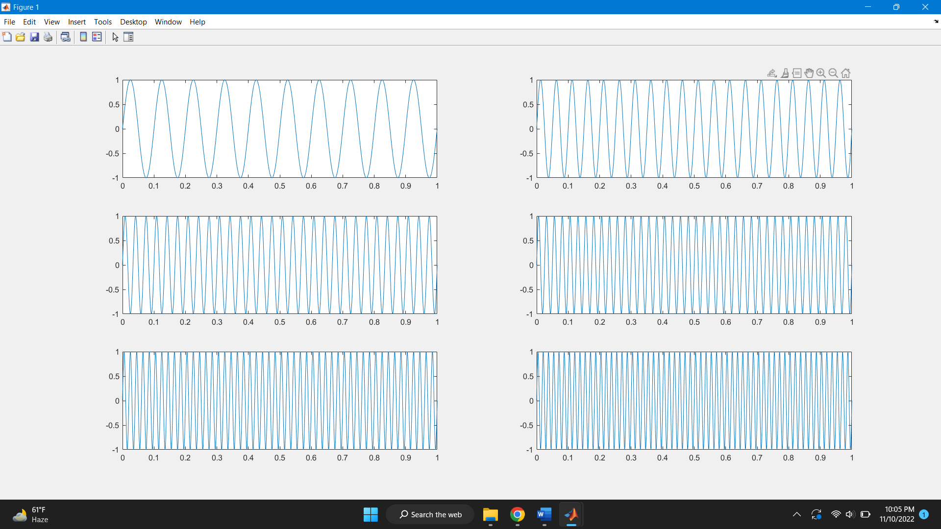

**Code for Frequency domain representation:**

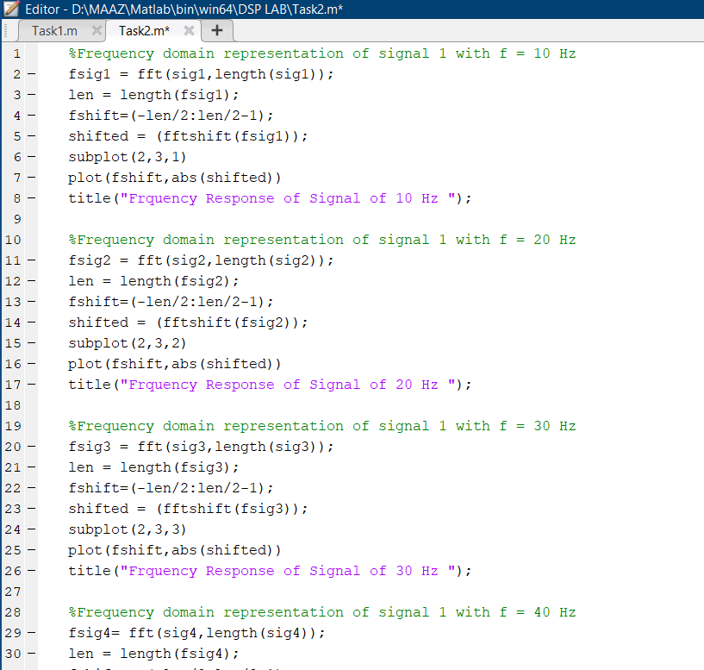

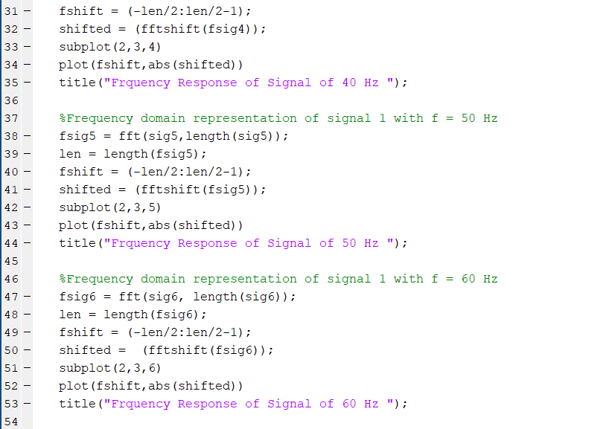

**Output:**

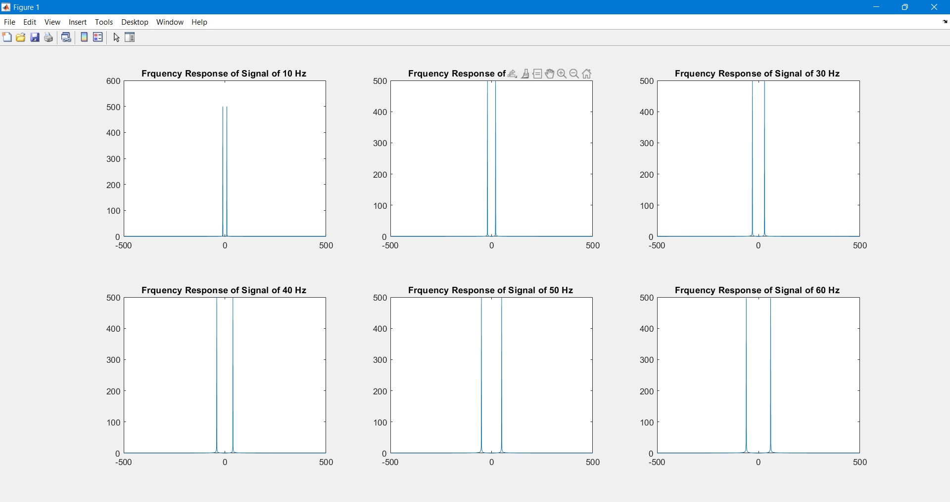

**Task 2: Compare** the figure 1 and 2 (Generated by your code)

Figure 1 is basically the time domain representation of the 6 signals with different frequencies i.e., 10Hz, 20Hz, 30Hz, 40Hz, 50Hz and 60Hz. On the other hand, in figure 2 we basically shifted all of the six signals to frequency domain (discrete signal) and we represented the plots of the frequency domain in figure 2.

**Task 3:** Add all the signals generated in step 1 and get a composite signal. (Which may be considered as a voice signal)

**Code:**

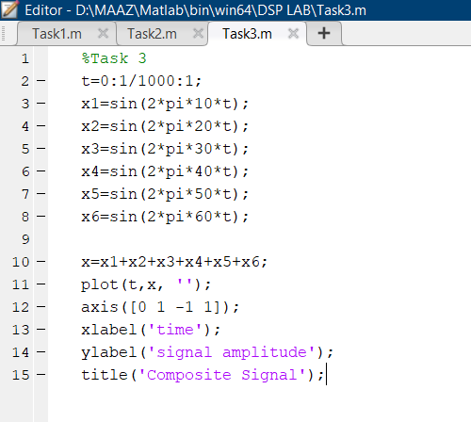

**Output:**

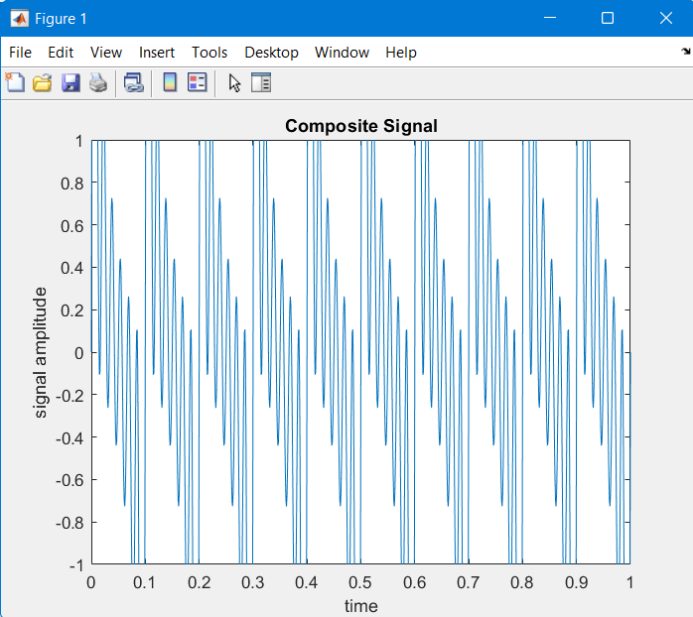

**Task 4:** Obtain and plot the time and frequency domain representation of the composite signal as shown in figure

**Code:**

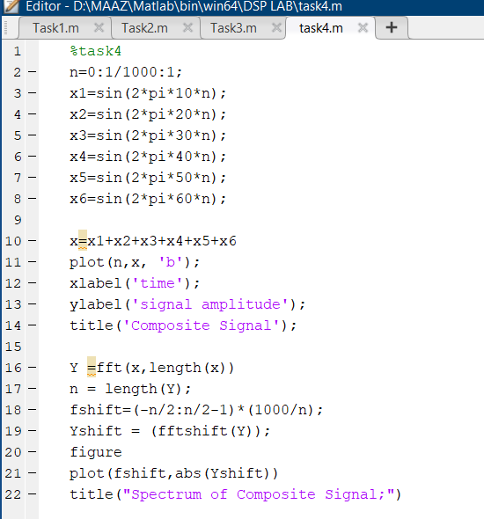

**Output:**

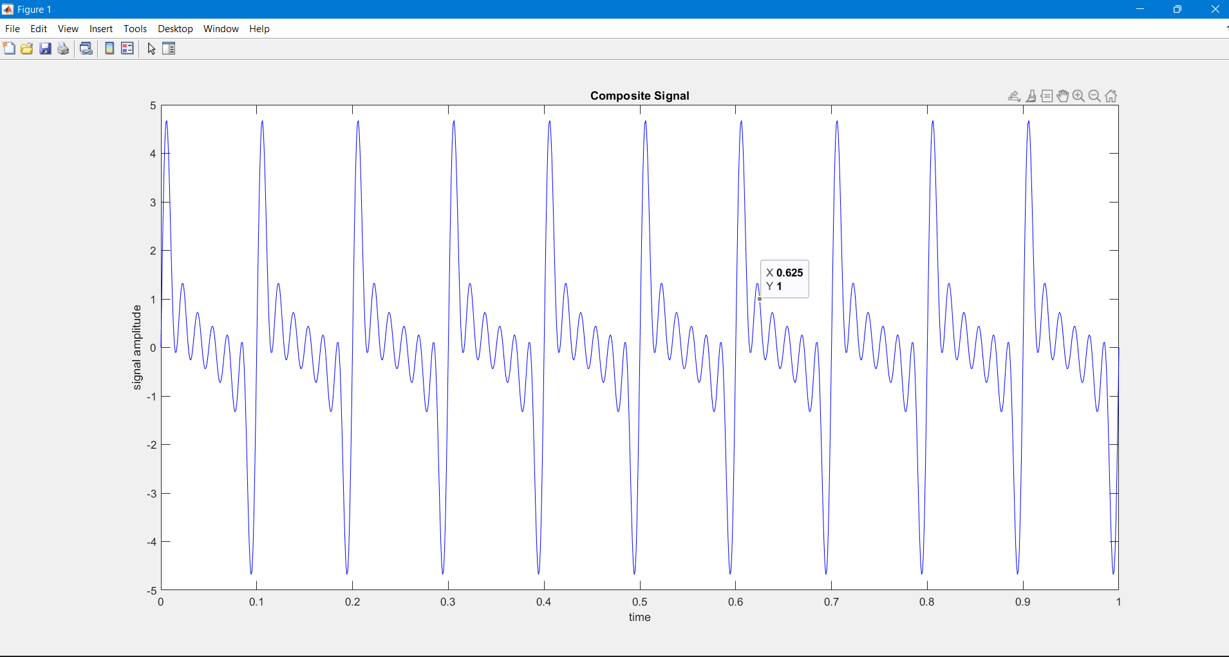

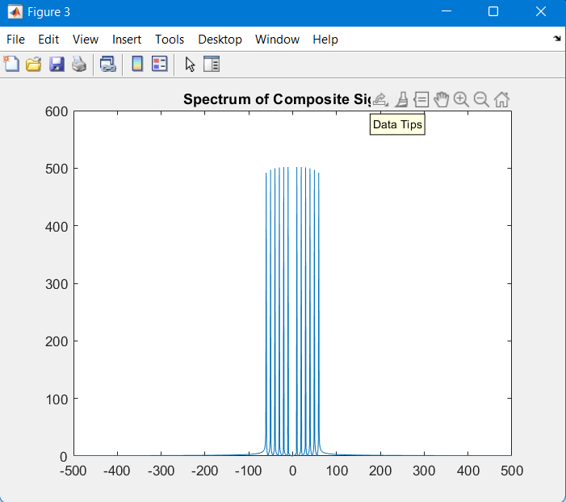

**Task 5:** Confirm that you are getting all the frequency generated in step 1 above.

Yes, confirm we are getting all the frequencies above if I compare it with the figure form Lab Document.

**Task 6**: Generate some unwanted signal having frequencies say 80Hz and 100Hz (assume these signals represent noise) and different amplitudes say 0.5 and 0.7

**Code:**

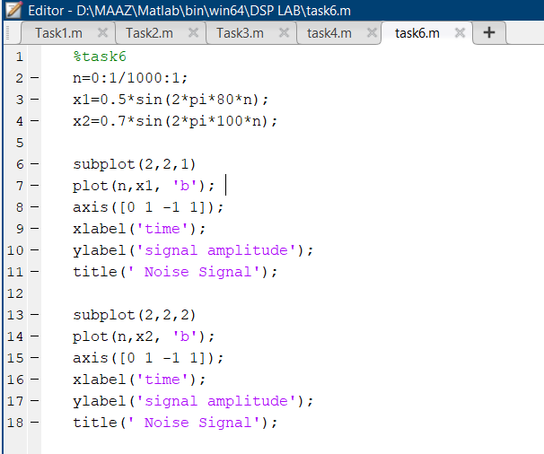

**Output:**

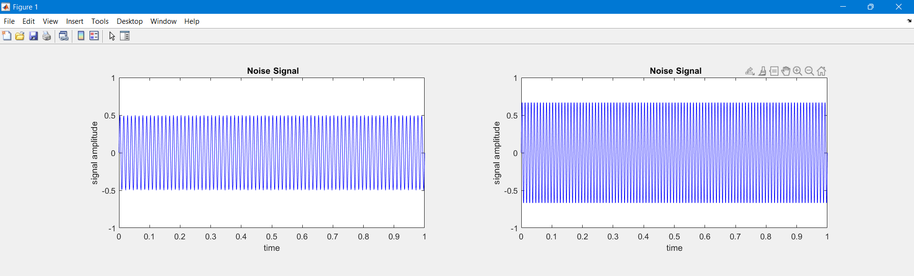

**Task 7:** Obtain both time and frequency representation of noise and confirm they have different power as shown in figure 4

**Code:**

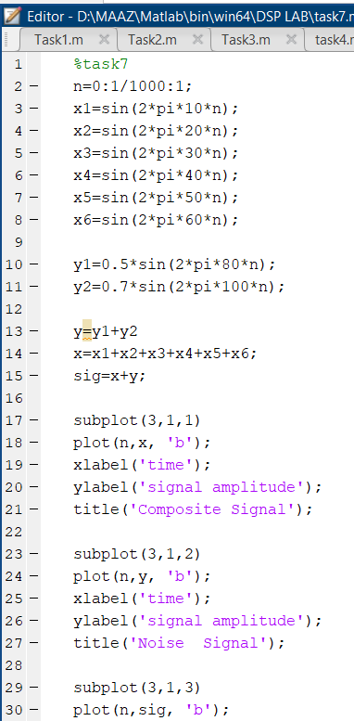

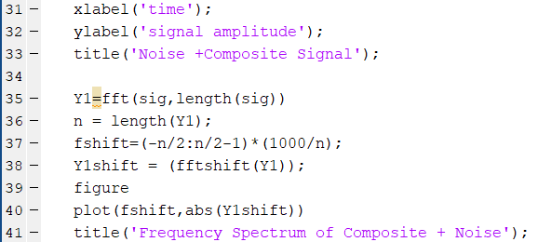

**Output:**

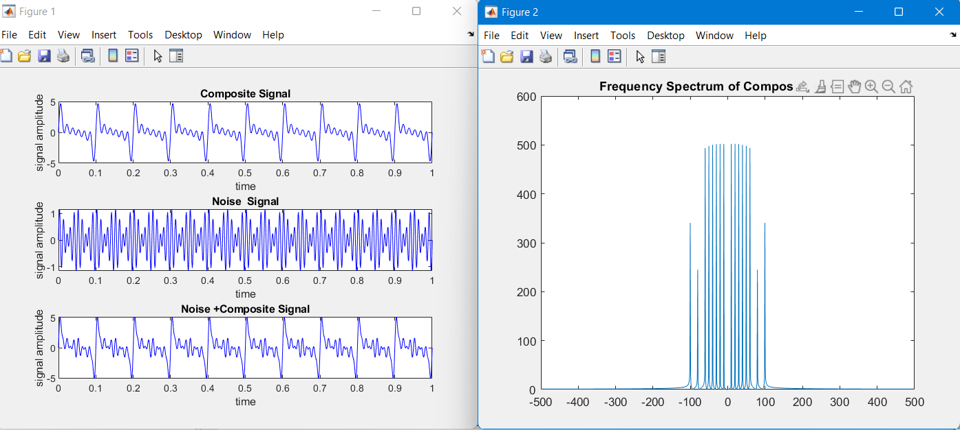

**Task 8:** Add the noise to the composite signal (assume the noise is added to the signal during transmission) and obtain frequency spectrum.

**Code:**

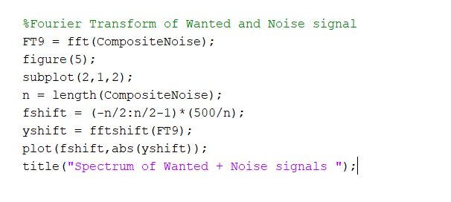

**Output:**

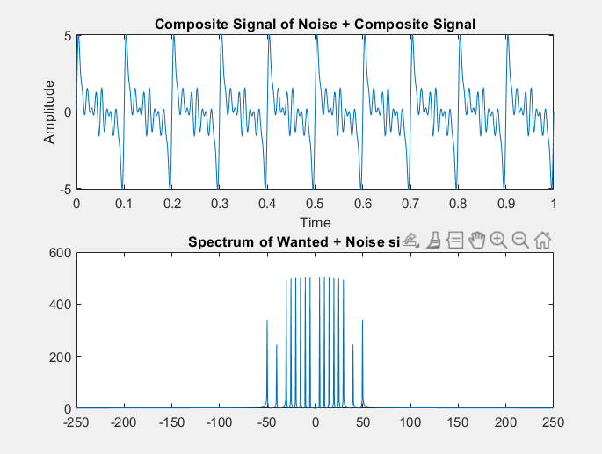

**Task 9:** Final Remarks/Conclusion:

* First, we started off with 6 signals of different frequency (10,20,30,40,50 and 60).
* Then we also examine them in frequency domain on discrete time.
* Then we added all the signals all together.
* We made a composite signal and added them together.
* We created noise signal of 80 and 100Hz.
* Then we plotted them in order to see the difference.
* Finally we add the noise with composite signal to obtain frequency spectrum.